

G6 Internet Explorers



keeping plants alive.

**Prepared by:**

**Daria Sukonnova**

**Shane Thacker**

**Jeremy Naupay**

**Brian Dean**

**Submitted to RMIT**

**16 February 2020**

**Course Instructor:**

**Anthony Clapp**

Contents

Introduction 3

Team Profile 3

Team Name 3

Personal Information 3

Team Test Results 4

Group Processes 11

Career Plans 11

Ideal jobs comparison: 11

Tools 13

Project Description 14

Overview 14

Motivation 14

Landscape 14

Detailed Description 15

Aims 15

Goal 1 15

Goal 2 15

Goal 3 15

Goal 4 15

Goal 5 15

Plans and Progress 16

Background notes and dead ends. 19

Roles 20

Scope and Limits 21

Tools and Technologies 22

Testing 23

Timeframe 24

Risks 25

Group Process and Communication 27

Skills and Jobs 28

Group Reflection 33

References 35

# Introduction

With the growth in high-rise living, balcony gardens are becoming increasingly popular. (*As the popularity of apartment living increases, downsizing a garden becomes a new challenge - ABC News (Australian Broadcasting Corporation)*, no date). Science recognises that plants contribute to reducing the amount of toxins in the air and provide benefits to mental health and reduced stress. Balcony gardens are entirely dependent on humans. (*How a pot plant or five is good for you | Pursuit by The University of Melbourne*, no date).

However, many urban dwellers struggle to keep their potted plants or balcony gardens healthy and alive. **This is why the world needs gardenMates.**

GardenMates is a mobile phone application that connects to one or more sensors which are placed in the soil of the pot or garden bed. The sensors measure soil moisture, soil ph, ambient light and ambient temperature and displays this information relative to the specified plant so that would be gardeners and the non-green thumbed can monitor optimum growing conditions.

In the following pages we introduce the members of the team working on this project.

The project details including deliverables and risks, as well as discuss the project management process we have implemented. The members of the G6 Internet Explorers team invite you to discover more about gardenMates.

# Team Profile

## Team Name

The Team name of G6 Internet Explorers was chosen to reflect our group numbers ie six and the fact that we would be using the internet to research our project. G6 also has connotations of an elite group such as the Group of Seven Organisation of Advanced Economies.

## Personal Information

My name is ***Brian Dean*** and my RMIT student number is S3831349 and I am a member of the G6 Internet Explorers Team. I was born in Brisbane, though spent much of my working life in Sydney. My wife and I are now living on the northern beaches of Cairns in a little spot called Yorkeys Knob, with our twelve year old ginger rescue cat called "Pumpkin", who shares by birthday day and month. I enjoy reading, mainly sci fi fiction, cooking and a spot of gardening. Currently self employed as a technology consultant to the hospitality and tourism sector, having worked in that industry and software houses for many years. I am enrolled in this Bachelor of I.T. degree to fill in the many holes in my knowledge and for accreditation for all those years of doing.

My name is ***Daria Sukonnova***, my RMIT student number is S3812576 and I am a member of the G6 Internet Explorers Team. I was born in the Russian city named Khabarovsk but then we moved to the Northern capital of Russia - St. Petersburg. I enjoy doing many things such as playing the piano or drawing. My biggest passion is reading books of any genre. My dream is to become an Artificial Intelligence Engineer. I find writing code quite enjoyable. My first program was a primitive game on Unity which was created with a tutorial. Since that time I really like solve code challenges on Python. Hope that in the near future I will develop the necessary skills to achieve my goal.

My name is ***Jeremy Naupay*** my RMIT student number is S3831039 and I am a member of the G6 Internet Explorers Team. I have grown up in the Sydney area since the day I was born. I love using my spare time to play around with different operating systems and brushing up on knowledge base. I have worked in I.T for over 2 years now as an IT Support Officer and looking forwards to be a Chief Information Officer in the future. Sometimes i do love to plan our model train sets as a hobby, but i also enjoy just playing video games and working on modding games in general.

My name is ***Shane Thacker***, and my current home is Toowoomba Queensland. My RMIT student number is s3827970 and I am a member of the G6 Internet Explorers Team. Born in Adelaide, I moved to Queensland when I was eighteen, where I got a job in the furniture industry. By twenty, I was going back and forth to Indonesia to train the suppliers on how to sand, prepare, upholster, assemble, glaze and upholster furniture for the Australian company I was working for. At twenty-one, I made the permanent move to Indonesia working for that company then eventually by the time I was twenty-two started my own teak outdoor furniture company. After the 2008 global crisis wiped out my customers, then me off the map, I worked for a European company managing their properties in Indonesia. When those properties were sold off in 2015, I joined an international school and became the school director.

My main interests are barbeque low and slow and fishing, both of which involve knocking back a few cold beers. I have three kids the youngest being six and extremely naughty, most likely because he is too spoilt. Flight simulation is my main “do on own” hobby, but I rarely find time these days.

I am working towards a Bachelor of International Business where I hope to move into

a management position of an international company within the next five years.

## Team Test Results

In the section below we review the team composition based on the results of the Meyers Briggs personality test and several others. It is interesting to note that of the four members of the G6 Internet Explorers Team each have different Meyers Briggs types.

#### Meyers Briggs test

**Jeremy – INFJ (Introverted, iNtuitive, Feeling, Judging)**

**Daria – INFP (Introverted, iNtuitive, Feeling, Perceiving)**

**Brian – ENFP (Extraverted, iNtuitive, Feeling, Perceiving)**

**Shane – ESTJ (Extraverted, Sensing, Thinking, Judging)**

**Cognitive functions:**

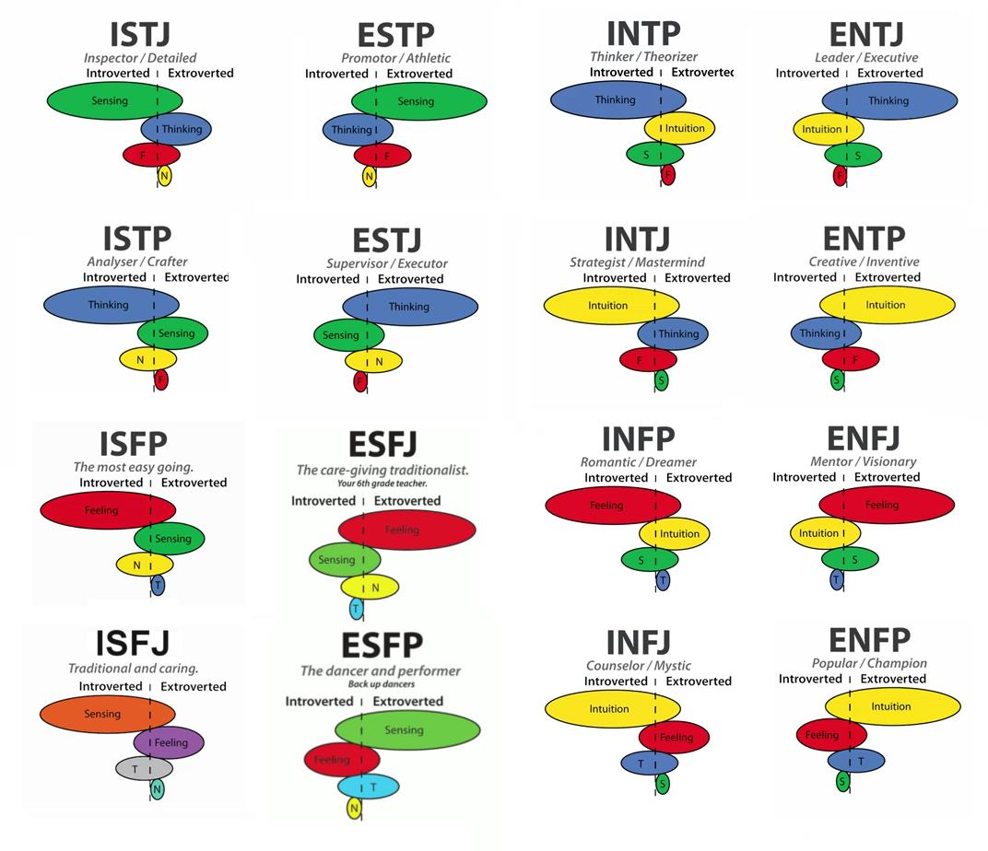

|  |  |
| --- | --- |
| Description of Personality Types: | |
| **INFJ**  **(The Advisor)**  People with an INFJ personality type tend to be determined, reserved, and altruistic in their behaviour. They are idealists and are passionate about making the world a better place. They enjoy close relationships with a few people, but usually prefer working alone. | **INFP**  **(The Empath)**  People with an INFP personality type tend to be reserved, idealistic, and adaptable in their behaviour. They are curious people, often lost in thought. They enjoy being by themselves or with small groups of people and prefer to listen to and contemplate the thoughts of those around them. |
| **ENFP**  **(The Encourager)**  People with an ENFP personality type tend to be energetic, adaptable, and inventive in their behaviour. They like to think up new, creative ideas and love sharing them with other people. They thrive in group settings and enjoy meeting new people. | **ESTJ**  **(The Commander)**  People with an ESTJ personality type tend to be organized, loyal, and hard-working in their behaviour. They are good, law-abiding citizens with a desire to lead. They are very principled and thrive when they are helping and encouraging others to follow a set of beliefs and values. |

ESTJ – Shane

ENFP – Brian

INFJ – Jeremy

INFP – Daria

P

I

NF

E

J

ST

This diagram clearly shows how the personality traits of all group members intersect. Everyone got different test results, which means that we are of different personality types. For example, Shane and Daria have opposite results, so it is very important for them to learn to (?) understand each other's way of thinking and working. Jeremy and Brian, on the other hand, both have two similar letters - N(iNtuitive) and F(Feeling). They have some analogous traits such as tendency to process emotionally and focus their attention on the bigger picture. However, Jeremy is I(Introverted) and J(Judging) type, while Brian is E(Extroverted), P(Perceiving) type so they need to find an approach to each other's features.

|  |
| --- |
| How can these types communicate effectively with each other? |
| **INFJ&INFP (Jeremy, Daria):**  INFPs and INFJs tend to prefer time alone, process emotionally, and focus their attention on the bigger picture. However, INFPs are generally more flexible in their plans, while INFJs tend to follow schedules and processes. INFPs should be consistent around INFJs, while INFJs should give INFPs the freedom to move at their own pace. |
| **INFJ&ENFP (Jeremy, Brian):**  INFJs and ENFPs both tend to process emotionally and focus their attention on the bigger picture. However, INFJs tend to follow schedules and prefer to spend time alone or in small groups, while ENFPs are generally more flexible in their plans and thrive in larger group settings. INFJs should work to build personal connections with ENFPs, while ENFPs should allow INFJs space to recharge by communicating via email when necessary. |
| **INFJ&ESTJ (Jeremy, Shane):**  INFJs and ESTJs are very different; though they both prefer to follow a plan, INFJs are reserved, empathetic, and creative, while ESTJs are outgoing, logical, and present-focused. INFJs should work on expressing themselves more rationally around ESTJs. ESTJs should listen to and show empathy toward INFJs, allowing them space to be alone, when needed. |
| **INFP&ENFP (Daria, Brian):**  INFP and ENFP personalities both tend to focus on the overall perspective, consider the feelings of themselves and others, and prefer to follow flexible schedules. However, INFPs tend to be more reserved and ENFPs are generally outgoing. INFPs should feel open to share their feelings with ENFPs while ENFPs should respect INFPs desire to spend time alone. |
| **INFP&ESTJ (Daria, Shane):**  INFPs are generally emotionally intuitive, reserved, creative, and adaptable, while ESTJs are outgoing, rational, present-focused, and organized. INFPs should be direct and honest when addressing ESTJs. ESTJs should be encouraging around INFPs, allowing them space to be alone. |
| **ENFP&ESTJ (Brian, Shane):**  ENFPs are generally emotionally intuitive, creative, and adaptable, while ESTJs are rational, present-focused, and organized. ENFPs should be direct and honest when addressing ESTJs. ESTJs should encourage ENFPs by avoiding overt criticism. |

|  |
| --- |
| How can these types build trust? |
| **INFJ&INFP (Jeremy, Daria):**  INFPs are more likely to trust INFJs who allow freedom to follow a loose schedule, while INFJs tend to trust INFPs who follow through on set commitments. |
| **INFJ&ENFP (Jeremy, Brian):**  INFJs tend to trust ENFPs who follow through on set commitments, while ENFPs are more likely to trust INFJs who allow them the freedom to follow a loose schedule. |
| **INFJ&ESTJ (Jeremy, Shane):**  INFJs are likely to trust ESTJs who show concern for INFJs’ feelings. INFJs need to feel safe and connected to build lasting relationships.  ESTJs will grow to trust INFJs who can be more direct and level-headed; INFJs should also allow ESTJs the independence they need to thrive. |
| **INFP&ENFP (Daria, Brian):**  INFPs are more likely to trust ENFPs who listen to and affirm INFPs’ ideas.  ENFPs tend to trust INFPs who are open, caring, and seek to create personal connections with them. |
| **INFP&ESTJ (Daria, Shane):**  INFPs are more likely to trust ESTJs who appreciate their creative ideas and allow them to follow a flexible schedule; ESTJs should be attentive to the needs of INFPs.  ESTJs tend to trust INFPs who share their thoughts openly and avoid strong emotional reactions; INFPs should also recognize and appreciate ESTJs’ practical thinking. |
| **ENFP&ESTJ (Brian, Shane):**  ENFPs are more likely to trust ESTJs who are supportive and allow ENFPs to follow a flexible schedule, while ESTJs tend to trust ENFPs who communicate openly and avoid strong emotional reactions. |

|  |
| --- |
| How can these types resolve conflicts? |
| **INFJ&INFP (Jeremy, Daria):**  Since INFPs and INFJs are both Feeling personalities, they should each focus on expressing how a situation affects them emotionally, while showing empathy to the other person. Though both INFPs and INFJs dislike confrontation, conflict should be addressed in a timely manner. To avoid stress, INFPs and INFJs should both be open about their perspectives and take space to reflect. |
| **INFJ&ENFP (Jeremy, Brian):**  Since INFJs and ENFPs are both Feeling personalities, they should each focus on expressing the emotional impact of a situation, while remaining empathetic to one another. To avoid stress, INFJs and ENFPs should both be open about their perspectives and ENFPs should encourage INFJs to take space to reflect, if needed. |
| **INFJ&ESTJ (Jeremy, Shane):**  ESTJs should give INFJs the space and support they need to feel safe to express themselves. INFJs need to be direct and logical when addressing a problem with ESTJs; they should allow ESTJs to work through each problem individually. |
| **INFP&ENFP (Daria, Brian):**  Since INFPs and ENFPs are both Feeling personalities, they should focus on communicating how they feel, while remaining calm and empathetic. To avoid a stressful confrontation, INFPs should be more vocal about their perspective, while ENFPs should avoid overcrowding INFPs, allowing them to take space to reflect. |
| **NFP&ESTJ (Daria, Shane):**  INFPs tend to express themselves emotionally, while ESTJs prefer to work through issues logically. INFPs should be open about their perspective with ESTJs, avoiding the use of overly emotional phrasing and allowing ESTJs to sort through each issue individually. ESTJs should focus on listening to INFPs and communicating their side calmly. |
| **ENFP&ESTJ (Brian, Shane):**  ENFPs tend to express themselves emotionally, while ESTJs prefer to work through issues logically. ENFPs should address issues directly with ESTJs, avoiding the use of overly emotional phrasing and allowing ESTJs to sort through situations individually. ESTJs should focus on listening to ENFPs without interrupting and communicating their side in a calm, patient tone. |

|  |
| --- |
| How can these types work together? |
| **INFJ&INFP (Jeremy, Daria):**  Both INFPs and INFJs bring creative solutions and empathy to a workplace; however, INFPs also offer a flexible attitude, while INFJs offer commitment and dedication. INFPs can help INFJs learn to adapt to unexpected situations, while INFJs can help INFPs achieve their personal goals. |
| **INFJ&ENFP (Jeremy, Brian):**  Both INFJs and ENFPs bring creative solutions and empathy to a workplace; however, INFJs also offer commitment and dedication, while ENFPs offer a flexible attitude. INFJs can help ENFPs achieve their professional goals. ENFPs can help INFJs step outside of their comfort zone and try new things. |
| **INFJ&ESTJ (Jeremy, Shane):**  INFJs bring creative ideas and considerate solutions to a work environment. They can help ESTJs consider how their decisions will impact others.  ESTJs offer attentiveness and practical thinking. They can help INFJs share their thoughts more openly with others. |
| **INFP&ENFP (Daria, Brian):**  Both INFPs and ENFPs bring caring, creative thinking and adaptability to a work environment. However, INFPs are also strong, independent workers, while ENFPs are social and inviting. INFPs can help ENFPs become better listeners, while ENFPs can help INFPs express themselves more directly. |
| **INFP&ESTJ (Daria, Shane):**  INFPs bring innovative solutions and empathetic reasoning to a work environment, while ESTJs offer attention to detail and goal-oriented planning. INFPs can help ESTJs consider others when making decisions, while ESTJs can help INFPs follow through on accomplishing personal or professional goals. |
| **ENFP&ESTJ (Brian, Shane):**  ENFPs bring innovative solutions, empathetic reasoning, and adaptability to a work environment, while ESTJs offer attention to detail, logical decision-making, and goal-oriented planning. ENFPs can help ESTJs consider others when making decisions, while ESTJs can help ENFPs achieve personal and professional goals. |

|  |
| --- |
| How can these types deal with change? |
| **INFJ&INFP (Jeremy, Daria):**  Due to their Perceiving trait, INFPs tend to be naturally accepting of new situations. INFJs, however, may have a more difficult time, since they tend to follow set plans. INFPs should help INFJs focus on the positive aspects of change and create a new plan or routine. |
| **INFJ&ENFP (Jeremy, Brian):**  Due to their Perceiving trait, ENFPs tend to be naturally accepting of new situations. INFJs may have a more difficult time since they tend to prefer consistency. ENFPs should help INFJs focus on the positive aspects of change and create a new plan or routine. |
| **INFJ&ESTJ (Jeremy, Shane):**  Because they tend to follow set plans, INFJs and ESTJs may have a difficult time adapting to change. They should consider the positive aspects of a new situation and be willing to modify their plans. |
| **INFP&ENFP (Daria, Brian):**  Due to their Perceiving trait, INFPs and ENFPs tend to be naturally accepting of new situations. They are adaptable personalities who tend to crave unexpected experiences and appreciate positive change. |
| **INFP&ESTJ (Daria, Shane):**  Due to their Judging trait, ESTJs tend to have a difficult time adapting to a new situation. INFPs, however, usually have a flexible attitude and adjust well to change. INFPs should help ESTJs consider the positive aspects of change and create a new plan to achieve their goals. |
| **ENFP&ESTJ (Brian, Shane):**  Because they tend to follow set plans, ESTJs may have a difficult time adapting to a new situation. ENFPs, however, usually have a flexible attitude and adjust well to change. ENFPs should encourage ESTJs to focus on the benefits of the situation. |

#### Learning Style Tests Results

All members of our team are visual. Visuals learn by reading or seeing pictures. They understand and remember things by sight. Visuals like to see what they are learning and often close their eyes to visualize or remember something. According to this results, each person in our group perceive information visually and this knowledge will be useful during our work on the project.

#### Learning tips for visuals:

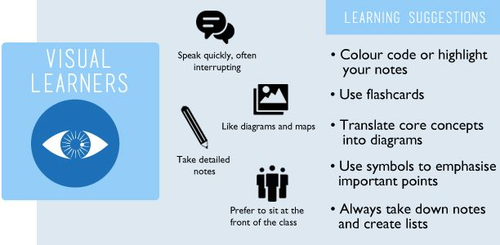

#### Other tests results

##### Brian’s test result:

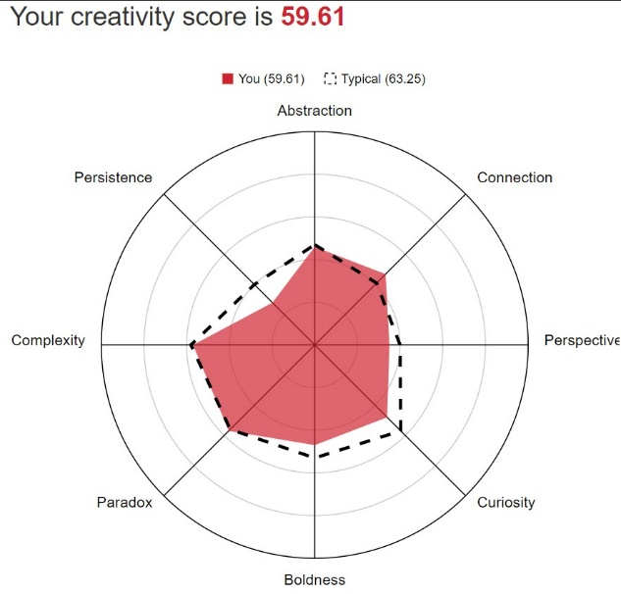

This test evaluates creativity. Working in a group on a project often requires a creative approach, so such tests can be useful in determining the strengths and weaknesses of a person. One of the strongest Brian’s creativity features is connection which means the ability to make connections between things that don't initially have an apparent connection. This feature will help to solve problems arising in the work on the project in an unusual way.

##### Jeremy’s test result:

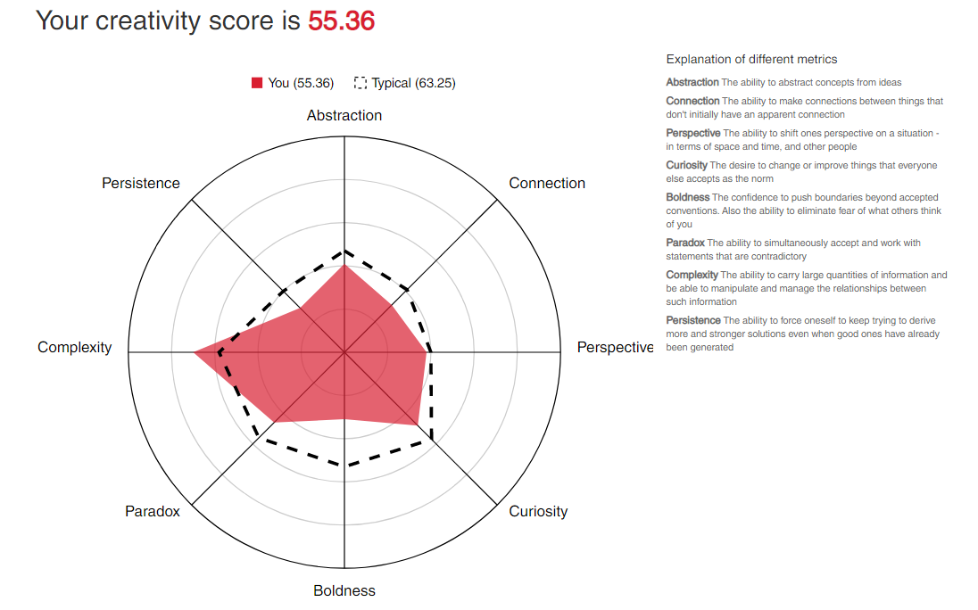

Jeremy has chosen the test on creativity too. His strongest feature is complexity - the ability to carry large quantities of information and be able to manipulate and manage relationships between such information. It will be incredibly useful in working with a big amount of text and information.

##### Shane’s test result:

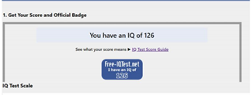

Shane has chosen IQ test. As he wrote in his Assignment 1 project, IQ test would not necessarily influence behaviour in a team environment. It would be more rational to draw conclusions based on abilities and personalities.

##### Daria’s test result:

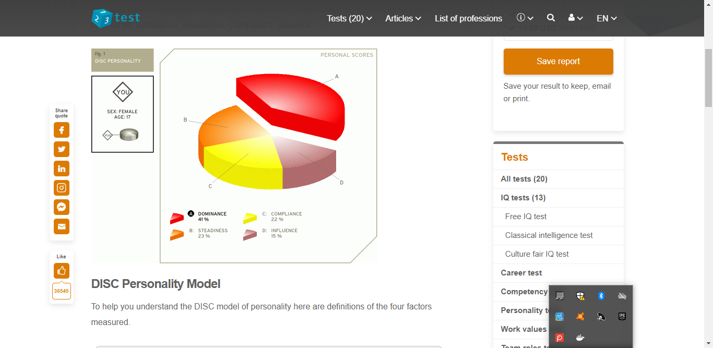

Daria has done the DISC test. Her result is dominance which means that she is responsible and likes changes and challenging tasks.

## Group Processes

At the time the work on the Assignment 2 began, the members of G6-Internet-Explorers group were not familiar with each other. However, this did not prevent the group from working cohesively and effectively, during the term of the assignment.

Cooperation was one of the strongest sides of our group (and it is still true).

Despite the fact that some of us live in different time zones, we were able to find time for regular conferences where we discussed the progress of our work. Everyone was respectful and organized. Passion for work is the key to success and our group have proved it.

Everyone had a huge amount of ideas and interesting visions of our work. Our group process consisted of discussing our working plan on the regular video-conferences, chatting in Microsoft Teams and posting our work on GitHub.

All in all, our group worked really efficiently on Assignment 2. The change that we will introduce is even better communication as now we have further developed our group working skills.

## Career Plans

### Ideal jobs comparison:

Every member of our team has different experience, dreams and career plans. Though, that does not mean that there are no common elements in our future job plans.

#### Ideal jobs:

Jeremy - Chief Technology Officer

Brian - Solution Architect

Shane - Principal Data Insights Analyst

Daria – Machine Learning Engineer

|  |  |  |  |
| --- | --- | --- | --- |
| **What is the difference?** | | | |
| **Chief Technology Officer**  **(Jeremy)**  The main work of the Chief Technology Officer is making decisions for the overarching technology infrastructure that closely align with the organization's goals. | **Solution**  **Architect**  **(Brian)**  A Solution Architect is responsible for the design of one or more applications or services within an organization and is typically part of a solution development team. | **Principal Data Insights Analyst (Shane)**  A Principal Data Insights Analyst uses data analytics to develop tools that provide clear, accurate and insightful information. | **Machine Learning Engineer**  **(Daria)**  An artificial intelligence engineer works with algorithms, neural networks and other tools to advance the field of artificial intelligence in some way. |
| **What is similar?** | | | |
| They need to have a deep IT knowledge and they should be aware of new and existing technologies and use their technical vision for a particular solution. | | | |

**Career plans comparison:**

Jeremy: “After finishing my bachelor’s degree, I am either thinking of doing a masters or moving into a degree in business. With these steps I am hoping it will lead me to greater opportunities of growth to then be in a CIOCIO position in the next 8-10 years.”

Brian: “Skills and knowledge I will need to acquire are in the areas of engineering and software architecture design, cloud development and IT architecture. Obtaining positions with companies developing and working with cloud technologies will provide real world experience. Importantly obtaining a degree in IT will be an excellent start to filling these gaps in my knowledge, as well as further learning of AWS services.”

Shane: “My primary career interest is working in the area of higher management for a multinational corporation. With my current experience as owner-director of an international furniture manufacturing and export company, global property management and managing an international school, I feel that my personal on the job experience is suffice. In the modern-day, however, I do require more skills and actual “black and white” qualifications. ForFor this reason, I am undergoing a Bachelor of International Business which I hope shall be acquired within the next three years.”

Daria: “In parallel with studying at the University, I will be studying Machine Learning in Python using online courses. After mastering the essential skills, I can get an internship as a data science engineer. My next step is working as a data science engineer for several years to get an experience and then find a work in an international company as Machine Learning Engineer”

|  |  |  |  |
| --- | --- | --- | --- |
| **What is different?** | | | |
| **Shane**  Shane relies on his previous career experiences as well as on developing more skills and obtaining “black and white” qualifications | **Brian**  In addition to obtaining a degree in I.T., Brian is planning to learn AWS technologies. | **Jeremy**  Jeremy’s plan is to do masters or move into a degree in business. | **Daria**  Daria is going to develop necessary skills using online courses. |
| **What is similar?** | | | |
| To achieve their goals, everyone needs to get the necessary skills and education, that will take several years. | | | |

## Tools

G6 Internet Explorers Team website:

<https://g6-internet-explorers.github.io/>

G6 Internet Explorers Team Repository:

<https://github.com/G6-Internet-Explorers/RMIT-Assignment-3>

The G6 Internet Explorers Team utilised Microsoft Teams available through our RMIT Office 365 account to manage online chat and communications. We also posted links to relevant videos and websites within the chat so as to provide context rather than uploading these to GitHub. Through this same platform we also trialled the use of OneNote and Microsoft planner, which we ended up not using to a great extent. Our Team meetings were held through zoom teleconferencing software which allowed us to discuss and contribute in real time as if we were in the same office. Zoom also allowed us to record the session, which allowed anyone not able to be present to catch up at a time that suited them. Zoom, while providing screen sharing capability also allowed for keyboard and mouse control to be switched to other team members during a meeting.

I do not believe the audit trail on the Git repository accurately reflects our individual contributions, as decisions to create or update folders and text or upload word and excel documents were often made and actioned during our teleconference Team meetings. As such the audit trail will show the username of the person hosting the teleconference rather than the team member who created the content. Additionally, with the problem of GitHub invitations apparently being blocked within RMIT email systems and subsequent delay in providing group access it is incorrect to attribute the initial flurry of activity to any one individual, as with appropriate access others would have contributed equally.

# Project Description

## Overview

gardenMates is a subscription-based mobile application package that you can purchase, which assists in the development of small to large scale agricultural development. This application package comes with a sensor device that can be added to a pot plant, or larger devices for a vegetable bed, to capture environmental data. This environmental data includes moisture content, soil type, soil requirements, soil characteristics and weather information. The information provided gives the customer live-data and life cycle assistance to ensure plant development is met in the best of conditions. gardenMates will also send you a notification to the app or an SMS message if it senses that the plant requires watering or some other factor such as overheating.

The outcome for this project is to have a commercially available, robust, reliable working application and system to suit the novice at-home gardener and students. We further hope to be able to expand on that technology to cater for large industrial vertical farms to increase their maximum capacity using a minimal carbon footprint.

### Motivation

Our motivation for pursuing gardenMates as a viable project stems from very real personal experiences of having pot plants, herbs and vegetables advertised as easy to grow, end up dead or ravished by insects or disease. Feedback from friends and relatives shows that this issue is not unique to us. Gardening can be very calming and therapeutic, less so when there are poor outcomes, so keeping plants alive for longer assists mental health. Having access to fresh herbs and vegetables is also important to physical wellbeing. The combination of a remote sensor an IOT device and a mobile phone application is very much on trend in I.T. terms with home gardeners and time poor city dwellers. We believe that our project, providing an innovative, cost effective, easy to use solution to gardening dilemma’s will provide a future employer with a better appreciation of our capabilities, problem solving abilities and exceptional team co-operation skills.

### Landscape

There are many different plant devices on the market today, some are quite similar to our gardenMates, but have their own unique features and market focus. For example, a device which is capable of measuring soil moisture, temperature, and light and automatically waters your plant with the built in water pump. Or another, self-contained automatic watering pot consisting of a soil sensor as well as the water reservoir built into a cavity in the pot.

There is competition between automatic and non-automatic plant watering and monitoring systems. The leading ones are PlantMaid (Subscribe, no date) and Parrot Pot (*Parrot POT*, 2017). Garden Mates has some similarities to Parrot Pot but the distinguishing feature of it is a sensor device that can be added not only to a pot plant, but also to larger sized garden

Interestingly our research uncovered a kickstarter start up based in the U.K. that is almost a mirror of gardenMates. The main difference being their sensor is designed for indoor use only which is a limitation gardenMates intends to overcome. (Subscribe, 2019)

## Detailed Description

### Aims

The primary focus of the gardenMates project is to provide to the masses a technological assistant to help in maintaining happy healthy balcony, indoor and micro gardens. This will be achieved using a sensor that takes measurement of soil and location conditions. The sensor or sensors pair to a small hub which provides access to the internet and the gardenMates servers. The gardenMates servers are then able to feed a mobile phone application with notifications, tips and the sensor measurements for each sensor location.

### Goal 1

The initial requirement is a suitable sensor device. The sensor must be of rugged manufacture, waterproof and able to stand up to outside conditions as opposed to the competition which only provide indoor use sensors. Four different measurements are required.

* Soil moisture
* Soil ph
* Ambient light
* Ambient temperature

Requires either Bluetooth or ZigBee communication protocols.

### Goal 2

Of equal importance to goal 1 is the mobile phone application. This will allow sensors to be registered and named ie “Basil”, “Roses” etc and provide a visual representation on the application of the sensor measurements and general plant health. The application will have a small database to maintain local information and growing tips.

The application needs to allow for very easy wizard based configuration setups and sensor pairing.

### Goal 3

One major point of difference between gardenMates and the competition is the ability to monitor the plant/s and notify the user of plant wellbeing while the user is away from home for an extended time. This is made possible by providing cloud-based server technologies that receive information from the sensors even when the mobile phone is not in range. The cloud-based systems will also provide a plant library which will provide tips and tricks on keeping the plant healthy.

### Goal 4

Required for goal 3 to be successful is the ability for the sensors to communicate with the cloud systems irrespective of the proximity of the mobile phone. This requires a small powered hub that can communicate via Bluetooth to one or more sensors and Wi Fi to the home network to relay information to the cloud.

### Goal 5

Apart from having the right soil composition, moisture, with an appropriate temperature and sufficient light, other issues for plant health is disease and insects. It is important to be able to determine what is eating the plant or with what disease it is inflicted with. Both of which may spread to other plants nearby, so early diagnosis is key. gardenMates will have the ability to send a photograph of the afflicted plant to an AI housed within the gardenMates cloud servers and for that AI to determine through machine learning the most likely cause and to offer recommendations for treatment.

### Plans and Progress

#### How it all began:

The origins of this project came about as we thought on how many times people have killed plants because of a lack of knowledge or poor time management. Usually we hear about this complaint among friends who would buy numerous potted plants and then eventually confessing that they died for some unknown reason or there just wasn’t enough time in their busy lives to provide adequate care. They would then purchase another plant or plants and the story would repeat itself. This is very costly and is quite common in the average household. Many people do not know how to properly look after their plants. Even if they wanted to, it would be hard to do so, as there is quite a bit of reading required in order to understand the complexity of plant growth. This project seeks to bridge the gap for average people, but also providing the option to go deeper into agricultural studies.

#### What’s in the box?

#### The Sensor

|  |  |
| --- | --- |
| Initial investigation suggested that a 4 in1 sensor marketed as Huahuacaocao Flower Care Smart Monitor by Xiaomi would provide the functionality required. In fact, it was the only commercial 4 in 1 sensor found. Initially the fact that this sensor only had Bluetooth communications caused some consternation as a point of difference between gardenMates and the competition is the ability to monitor plants (sensors) regardless of the proximity of the mobile phone app. This was resolved upon the discovery of a hub from the same manufacturer that offers Bluetooth, Wi Fi and ZigBee. |  |

#### The Hub

|  |  |
| --- | --- |
| XIAOMI Mijia Smart Multimode Gateway is a hub that is certified for WIFI, ZigBee and Bluetooth/Bluetooth Mesh. Currently supports 32 devices although recent information suggests this will be considerably expanded in the near future. Appears to be one of the few devices that supports all three communication protocols and as it is manufactured by the same company as the sensor integrates seamlessly. |  |

#### Mobile phone app

The following Business Process diagram outlines the steps for initial configuration of the mobile phone application once the application has been installed.

The diagram below shows the requirement for username / password validation and that the application options should also be saved to the database.

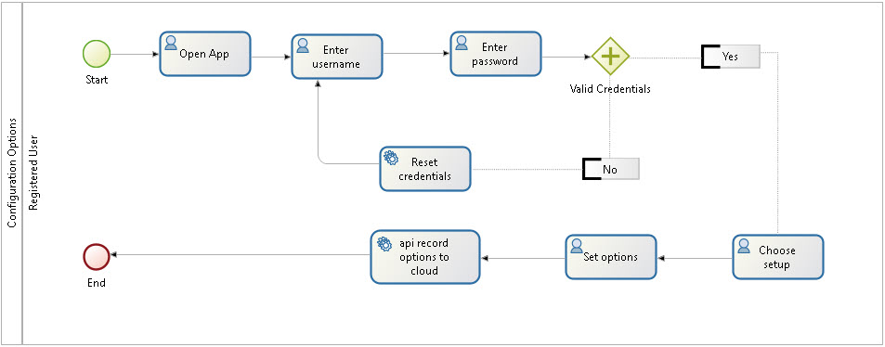

Some design concept mock-ups have been prepared to provide an idea of the look of the mobile phone app.

|  |  |
| --- | --- |
| Initial mock-up of the splash screen when the application first loads | Updated mock-up of splash screen |
| Original concept of home screen providing quick access to menu options. | Updated home screen where there is only one sensor. Allows at a glance check on that plant’s health. |
| When buying a new plant we like the idea of being able to scan the details in rather than selecting from a pick list of having to search. | Plant owners will be able to photograph their plant either for inclusion on the home page or to send to the A.I. for disease and insect diagnosis and recommendations. |

#### Infrastructure

All server technologies will be hosted in the cloud as outlined under the tools and technologies section.

### Background notes and dead ends.

**Development Environment**

The main goal of researching the possible development environments was identifying the most effective and economical software to develop a mobile application. We found this quite a challenge, as high-quality development software is often expensive. It was the first dead-end that we had to deal with when searching for software, as sometimes there were no satisfactory open source resources.

Mobile application development is divided into mobile app and backend creation. There are some variants of hosting backend: host it on a local server or in the cloud. We have chosen the cloud, because it provides better quality of output in lesser time, extreme security, regular updates, integration etc. The cloud technology chosen for our project is AWS, since it has a lot of benefits like flexibility, security and prebuilt API’s.

Backend also needs a framework. To select a backend framework, it is important to consider community and scalability. Our choice is Django, which is highly scalable and has an extensive community support.

As our app has a requirement for Artificial Intelligence it will be necessary to source a special framework model which will provide primitives for defining functions on tensors and automatically computing their derivatives. TensorFlow is the best variant for our app, it is flexible, easily trainable and open source.

An option for the back end database that could also provide a small footprint db on mobile devices that was considered is couchbase. It is supported by Amazon and has the ability for the mobile app to be offline and sync later. Couchbase unfortunately is not open source but a paid subscription which makes it a less desirable option. We believe that Apache’s offering of CouchDB a NOSQL database

In researching competitors in this space, it was interesting to come upon FarmBot a robotic gardener that can tend a small garden bed. Believe it would be an interesting proposition for a larger scale product offing from gardenMates, sometime in the future (*FarmBot | Open-Source CNC Farming*, no date).

Reviewing documentation from Zigbee alliance, we were particularly interested in Green Power. Green Power is a feature of Zigbee that allows for energy-harvesting technology to be used directly with the Zigbee stack. Green Power adds convenience to smart home markets by relieving the pain point that is replacing batteries that consumers may have to put up with (*Green Power*, no date)

The chosen sensor is fitted with a button battery and there is insufficient time or money to build our own, however if we were to explore designing our own sensor in the future this is technology we should look to adopt.

The first time use of the sensor, hub and app has to be super easy with as much automatic configuration as possible, we have suggested incorporating ProbMe capability into the application. The use of a QR code on the packaging will provide the passkey for ProbMe(‘ProbMe Simplifies Thing WiFi Connection’, 2014).

Should the project be passed to a different team they would need to continue to monitor the risks and identify new risks as they arose. Additionally continue to monitor the testing phases, analyse the data and keep the team updated with these results.

### Roles

Several roles are required for the GardenMates project. These are as follows:

1. Chief Technology Officer / Product manager (position filled by team member Jeremy) – The role of this person is the know the total scope of the project from start to finish, inside and out. This person will oversee every aspect of the project and ensure that each component has been achieved to expectations. Most likely, the PM will be one of the team members and the individual for this position may change as the project evolves and if it takes different directions.
2. Developer – This position would be best suited to a software engineer. The primary responsibility for this position is to create the code, test the code on various devices and find any bugs.
3. Solution Architect (position filled by team member Brian) – to work closely with the product manager/ Chief Technology Officer, developer and designer to ensure the app functions as expected and to steer the design to have maximum business earning potential.
4. Designer – This person would be working closely with the Developer to ensure the interface of the app is easy to navigate and aesthetically pleasing and conforming with branding. The designer would also need to develop a logo and company colours/branding.
5. Artificial Intelligence Engineer (position filled by team member Daria)– to develop the initial AI database that would be used in our app for diagnostics and advice received from the plant/soil data and user interface data when users are typing questions or uploading a photo of a sick plant.
6. Sales and Marketing and Customer Service – All team members would initially fill this position for our particular project, but down the track, as development goes farther, we would need a tech-savvy team with excellent communication skill to take the position full time looking after customers, reporting bugs to the team, moderating forums, organising advertising and promoting upgrades with offers and subscriptions.
7. Principal Data Insights Analyst (position filled by team member Shane) – to be continually monitoring that the application is functioning in a profitable way. To identify cost saving and other potential earnings. This person would also pinpoint where the project has room for expansion and establish the applications strong and weak elements.

### Scope and Limits

An integral part of the gardenMates project is the sensor and we are pleased to have been able to source a commercially available one that should be sufficient for most balcony gardens. Paired with the sensor is a hub from the same manufacturer which will provide a link between one or more sensors and the gardenMates servers.

The mobile phone app is in the business process workflow stage, with several mockups of various options of the app being created to give some idea of concept and look.

The database chosen to provide server and mobile phone synchronisation is CouchDB, an open source NoSQL database from Apache. Hosting will be through Amazon AWS.

Options for AI and machine learning for plant and disease / pest identification are being explored but will not be included in the initial release. It may be easier and more cost effective to use an API to access an existing system for plant and disease identification and recommendations.

Several open source plant libraries and databases are available with API connectivity to provide tips on growing selected plants. The most suitable option has yet to be determined.

An address checker API that can work in all of the target market countries for easy registration is required and has yet to be determined.

A payment gateway solution to record subscription payment options and be fully PCI compliant is required that will work in all of the target market countries. The most suitable for our purposes has yet to be determined.

### Tools and Technologies

##### Hardware

Huahuacaocao Flower Care Smart Monitor by Xiaomi – required sensor. Commercial terms not yet negotiated. No member of the team has used this device.

XIAOMI Mijia Smart Multimode Gateway – required hub. Commercial terms not yet negotiated. No member of the team has used this device.

##### Hosting

Amazon EC2 instance for database. Commercial terms not yet negotiated. No member of the team has prior experience with cloud hosting for a commercial product.

Amazon S3 storage. Commercial terms not yet negotiated. No member of the team has prior experience with cloud hosting for a commercial product.

##### Software

Apache couchdb server – open source – desirable from research, however no member of the team has direct knowledge.

TensorFlow – Free and open source - recommended, however no member of the team has practical knowledge of its application.

Django – Free and open source – recommended, however no member of the team has direct experience working with the framework.

Docker – Freemium software – containerisation. Desirable from workplace discussions, however no member of the team has direct knowledge.

Jenkins - Free and open source - automation server. Desirable from workplace discussions, however no member of the team has direct knowledge.

Address checker API – suitable product yet to be sourced.

Payment Gateway API - suitable product yet to be sourced.

Plant Library API - suitable product yet to be sourced.

### Testing



#### Stage 1 – Inhouse Testing

1. Front-End testing - ensuring the app is stable on both IOS and Android devices. Several different devices using each operating system such as handphones and tablets would be used. This can initially be performed using emulators.
2. Ensuring all features are functionable and communicating with the server and database.
3. Ensure advertising banners are functioning correctly
4. Back-End testing ensuring that updates can be pushed to the application on above platforms/devices.
5. Ensure the application is functionable with all screen sizes.
6. Ensure application is functionable with both WLAN and mobile networks.
7. Testing the sensors in extreme conditions such as putting them in a refrigerator, freezer, oven and submerging in water for different periods and that the sensors are still functionable within predetermined preset levels.

#### Stage 2 – Preparation

1. Create end user licenses, warnings, permissions, privacy statement, support pages.
2. Upload the application to Google Play and App Store not in public to test user downloading and installation.
3. Agree on versioning and pricing structure.

#### Stage 3 – Usability Testing

1. Our initial testing would be by using the teams family members and supplying them with a working prototype and the application. The reasoning behind this is that using people that are close to us, should there be an issue it would not be discussed in public, possibly causing negative press or social media hype.
2. Family members would range from an older group such as grandparents to a younger audience such as our brothers, sisters and cousins.
3. These age ranges also have diverse interests in gardening and using electronics and smart apps, so we would also be able to gauge the interest and usability of the product.
4. We would also test with a few people that do not speak English. The feedback from this would be how simple the app is to use and how informative the icons and navigation.
5. The compiled feedback from these individual groups would be an excellent indicator of bugs, navigation, and usability.

#### Stage 4 – Initial Real Testing Points

1. Ease of installation
2. Data requirements
3. Memory
4. Application speed
5. Conflicts with operating systems
6. Conflicts with other applications
7. Communication issues
8. Signup and Login
9. Error messages
10. Online and Offline usage

#### Stage 5 – Quality of Product

1. Statistics obtained from initial testing.
2. Security testing.
3. Data and storage usage at server level.
4. Testers personal feedback
5. Code review
6. Product meets acceptance criteria

#### Stage 6 – Beta Public Testing

For this stage we are going to require the services of:

1. Garden Professionals = 4 persons
2. Hobby Gardeners = 4 persons
3. General public = 30 persons
4. Technical experts to check quality assurance, security and scalability.

### Timeframe

| Course Week # | Brian | Shane | Jeremy | Daria | Full Stack Developer |
| --- | --- | --- | --- | --- | --- |
| Week 7 | General research on project topic | General research on project topic | General research on project topic | General research on project topic | Not currently employed |
| Week 8 | Formulation of ideas | Formulation of ideas | Formulation of ideas | Formulation of ideas | Not currently employed |
| Week 9 | Investigate database options | Begin wireframing application | Investigate sensor suitability and availability | Investigate software development applications | Not currently employed |
| Week 10 | Create user stories for app to test business logic and workflow | Create user stories for app to test business logic and workflow | Create user stories for app to test business logic and workflow | Create user stories for app to test business logic and workflow | Not currently employed |
| Week 11 | Brainstorm user story and experience | Brainstorm user story and experience | Brainstorm user story and experience | Brainstorm user story and experience | Not currently employed |
| Week 12 | Finalise Project Documentation | Finalise Project Documentation | Finalise Project Documentation | Finalise Project Documentation | Not currently employed |
| Week 13 | Finalise business process workflow based on brainstorming sessions | Finalise business process workflow based on brainstorming sessions | Finalise business process workflow based on brainstorming sessions | Finalise business process workflow based on brainstorming sessions | Review Application concepts and back end requirements |
| Week 14 | Review plant library database API and provide recommendation | Document subscription model and pricing | Draft licence agreement | Investigate open source API to AI/ML plant disease diagnosis | Begin coding |
| Week 15 | Research payment gateway options. | Draft subscription agreement | Draft user agreement | Report if suitable option or need to develop our own. | Continue Coding |
| Week 16 | Investigate weather forecast options API | Draft unsubscribe requirements | Draft unsubscribe requirements | Document QR Code requirements | Continue Coding |
| Week 17 | Document unsubscribe process | Draft Privacy agreement | Draft Privacy agreement | Investigate address checker API | Continue Coding |
| Week 18 | Draft marketing concepts | Draft marketing concepts | Draft marketing concepts | Draft marketing concepts | Continue Coding |
| Week 19 | Review business process workflow | Investigate suitable in app ads | Investigate suitable in app ads | Review business process workflow | Continue Coding |
| Week 20 | Test and document Alpha app and back end | Test and document Alpha app and back end | Test and document Alpha app and back end | Test and document Alpha app and back end | Deliver Alpha app and backend |
| Week 21 | Review all aspects of app and back end | Review all aspects of app and back end | Review all aspects of app and back end | Review all aspects of app and back end | Plant Library API |
| Week 22 | Test app and back end | Test app and back end | Test app and back end | Test app and back end | Make changes to app and back end per feedback. |

### Risks

1. Unwanted App – We run the risk that users don’t actually want an app to look after their plants. Although our team has personal experiences and feel positive that our product will improve peoples (and plants) lives, there is the possibility that the gardening community prefer to garden without technology.
2. The Application Too Popular – Contrary to the above, there is the risk that the product will become too popular. This could cause the team to quickly run out of money, run out of resources, not have enough people working on the project and the possibilities of overloading servers and resources.
3. Denied Hosting – There is a major risk that App Store or Google Play may not want to host our application. Users would be very wary to download and use an app that has not been vetted by these hosts as being secure.
4. Excessive Data – there could be the risk that the application and abundance of users creates too much data. This excessive data such as forums and user groups could also overload the user’s device or data plan causing them to lose interest in the app and uninstall it.
5. Wrong Development Partner – We have chosen AWS to be our hosting service for the gardenMates product, based on research and support in target market countries. The team’s unfamiliarity with using this or other cloud based hosting services in a commercial sense may lead to misunderstanding all aspects of the service offering, resulting in subscribing to an incorrect solution. AWS for example might provide enough resources on the interim, but other hosting such as Azure may in fact offer a better solution.
6. Security Breaches – There could be issues such as cross site forgery, insecure communications and insecure storage flaws. The risk of assuming native apps are inherently secure could cause us to overlook correct security measures. Hardware from China may be perceived in some markets as a potential security risk.
7. Supply – Our chosen commercially available sensor is produced in China and any of the following would seriously impact our ability to supply product. A trade war, shipping embargo, or a situation of manufacturing being closed down because of a pandemic such as Novel Caronvirus.
8. Investing in Wrong Platform – Similar to developers that spent a lot of money and resources developing apps for Blackberry, there is the risk that a newer or more popular platform takes the place of where we have invested.
9. Timing Risks – Shifting trends and newer technology could cause our product to be obsolete. A newer all in one product at a cheaper price with free delivery could become available prior to our product launch. A plant disease could quickly spread across the country and consumers may not want to buy plants or gardening products. Launching the product just after a major frost or hailstorm could cause users to question the positives of our product.
10. Marketing Risks – Selling our product too cheap could cause consumers to think that it is inferior and selling too expensive could cause consumers to question the purchase of our product.
11. Market Trends – There could be a brand new hobby, game or product to take the world by storm. Example: The Rubik’s Cube, Planking, Hover Boards to name a few. Consumers could possibly be swung by these trends and have a declined interest in gardening or our product.
12. Brand Risk – Our product “GardenMates” could possibly not be accepted by the gardening community. Where our team feels that the word “mates” is friendly and colonial Australian, our target consumer may feel the term is not appropriate for a product that they would buy or have in their home.
13. Reputation – A bad review on App Store or Google Play could seriously damage the products reputation and consumer confidence. There is also the risk that a competitor could give multiple false comments and ratings.
14. Appealing Design – Users may in fact not like our icons and the flow of the application. They might not understand the help and support pages or not like the language. The colour scheme albeit might appeal to our team, could in fact be a negative for us as users may find certain colour schemes more appealing.

### Group Process and Communication

We have found that communications have been as per previous assignment, very smooth and productive. The tools we used mostly were Microsoft Teams and Zoom Cloud Meeting. Our team members would poll for a time that was suitable for everyone and fortunately we would all be able to come together once per week.

This assignment however our communication was slightly different to the last one as previously our assignment was taking place over Christmas and New Year. This assignment however was more demanding on communications for us as the majority of our team members had to return to demanding work commitments and some members were dealing with getting children back to school or returning home from holidays.

Most often during our cloud meetings we would close by agreeing on a time for the next meeting. In the beginning once tasks were divided it would we would meet once a week but towards the final three weeks, often enough we would try to meet every three days to check on each other progress or assist each other if there were difficulties.

Our team agrees that because this was a new project, ideally to meet in person at a conference table and sketch the plans, our ideas and notes on a whiteboard would have been the most effective. Communicating via web conferencing once the project is up and running is fine, but the initial in person meeting would unquestionably have gotten us started of much smoother.

We did not have any group members not responding other than the two members as previous assignment that were uncontactable. It was easy to see via Microsoft Teams that members were checking messages at least once a day and being involved in the discussions and problem solving. As per previous assignment, we had already agreed that if for some reason a member was not responding, the tasks would be divided up and each member would volunteer to take on the task.

### Skills and Jobs

Manager(Project Lead)

As detailed in the section on roles earlier in this document the Project Lead would be the CIO, with skills and qualifications as outlined below.

|  |  |  |  |
| --- | --- | --- | --- |
| **Title:** | Chief Information Officer | **Job Category:** | Technical |
| **Group:** | G6 Internet Explorers Team | **Salary Range:** | Neg. |
| **Job Description** | | | | |
| **Roles and Responsibilities**  In this role you will be required to run the IT team in developing strategies to benefit the vision of Garden Mates. You will be reporting to the CEO on a regular basis providing up to date IT development strategies. Providing a valuable service in the strategy and vision of where the company will head towards. Keeping up to date with advancing IT technologies and business practices.   * Produce development goals and strategies ensuring infrastructure and solutions is meeting expectations and demand with advancing technologies. * Effectively prepare and communicate IT guides and practices * Deliver major IT solutions within a timely manner * Automate roles and responsibilities influenced by IOT trends * Direct existing and new IT systems   **Qualifications and Educational Requirements**   * Bachelor’s Degree in Computer Science * At least 7 years in IT cloud management and business development   **Preferred Skills**   * Strong Oral and written communication skills * Communicate effectively across cultural boundaries * Planning and budgeting skills * In-depth leadership skills in forming decisive teams   **Additional Notes**   * Work collaboratively | | | | |

For such a detailed project that spans multiple technologies, cloud computing, software and hardware, a Solutions Architect, with skills and experience as outlined in the following position description would be desirable to work collaboratively with all project team members.

|  |  |  |  |
| --- | --- | --- | --- |
| **Title:** | Solution Architect | **Job Category:** | Technical |
| **Group:** | G6 Internet Explorers Team | **Salary Range:** | Neg. |
| **Job Description** | | | | |
| **Roles and Responsibilities**   * Analysing the technology environment * Analysing enterprise specifics * Analysing and documenting requirements * Setting the collaboration framework * Creating a solution prototype * Participating in technology selection * Controlling solution development * Supporting project management   **Qualifications and Educational Requirements**   * At least eight years of working experience in one or multiple IT areas. * Experience in IT infrastructure and cloud development. * Experience in engineering and software architecture design. * Business analysis * DevOps * Project and product management.   **Preferred Skills**   * Excellent communication skills. * Deep analytical skills * Project and resource management skills   **Additional Notes**   * Influence and negotiate * Work collaboratively | | | | |

The ability of gardenMates to interpret images of unhealthy plants or insect damage, which is a point of difference to any competitor requires a Machine Learning Engineer.

|  |  |  |  |
| --- | --- | --- | --- |
| **Title:** | Machine Learning Engineer | **Job Category:** | Technical |
| **Group:** | G6 Internet Explorers Team | **Salary Range:** | Neg. |
| **Job Description** | | | | |
| **Roles and Responsibilities**   * Design machine learning systems * Research and implement appropriate ML algorithms and tools * Select appropriate datasets and data representation methods * Run machine learning tests and experiments * Perform statistical analysis and fine-tuning using test results * Train and retrain systems when necessary * Extend existing ML libraries and frameworks * Keep abreast of developments in the field   **Qualifications and Educational Requirements**   * A basic understanding of the fundamentals of Python programming * Additional programming skills in R, C++, and Octave * Ability to grasp some advanced mathematical concepts, including linear algebra, calculus, and graph theory * An understanding of data modeling * Experience in data analysis * A solid understanding of statistics and probability * A fundamental level of data visualization skills   **Preferred Skills**   * Physics * Communication Skills * Problem-solving skills   **Additional Notes**   * Time management * Strong focus on constant learning | | | | |

Principal Data Insights Analyst

|  |  |  |  |
| --- | --- | --- | --- |
| **Title:** | Principal Data Insights Analyst | **Job Category:** | Technical |
| **Group:** | G6 Internet Explorers Team | **Salary Range:** | Neg. |
| **Job Description** | | | | |
| **Roles and Responsibilities**   * Collaborating with the executive team to implement the data strategy * Scoping, Designing and Implementing reporting solutions * Working with Product to analyse usage, trends and suggest improvements * Working with Customer Success Managers to create value-add reporting for clients * Working with our R&D teams to surface data * Project Management of various data initiatives * Managing other internal and external resources to build reports   **Qualifications and Educational Requirements**   * 3+ years of business intelligence related experience * Data-driven and highly analytical * A strong passion and deep understanding of data * Strong technical skills (see section below) * An open mind and ability to quickly adapt to new environments * Excellent stakeholder & project management skills * Excellent business analysis skills * Excellent written and oral skills     **Preferred Skills**   * Databases:  SQL Server, SSIS, , PostgreSQL, AWS RedShift * Languages:  DAX, SQL, PLSQL, TSQL, Python * Software:  Power BI, Excel - Power Pivot & Power Query, Data Models, BPMN, Google Analytics and Data Studio, MixPanel, QuickSight   **Additional Notes**   * Excellent communication skills * CEFR C1 minimum English language. * Work collaboratively * Be prepared to travel. | | | | |

A Full Stack Developer is required for the project team to develop deliverables. Currently none of the existing team members have these capabilities. The requirements for the position are outlined below.

|  |  |  |  |
| --- | --- | --- | --- |
| **Title:** | Full Stack Developer | **Job Category:** | Technical |
| **Group:** | G6 Internet Explorers Team | **Salary Range:** | Neg. |
| **Job Description** | | | | |
| **Roles and Responsibilities**  In this role you will be required to develop and maintain both back-end and front-end systems. You will be required to incorporate a number of designs and processes, which support the Garden Mates vision as an application-based platform for household plant development. Streamlining the processes for excellent customer satisfaction through our platform.   * Develop Backend and front-end application architecture * Design and develop critical APIs * Meet technical needs as required * Develop interactive user interfaces on different applications   **Qualifications and Educational Requirements**   * At least 3 years of experience in producing complex systems * Computer science degree * Extensive understanding on HTML Javascript * Familiarity with NoSQL databases and database design. * Expertise in python, React Native. * Experience in REST API’s. * Experience in Containerisation essential.   **Preferred Skills**   * Excellent in both written and verbal communication skills * Familiarity with Adobe PhoneGap would be highly desirable. * Familiarity with Jenkins is desirable.   **Additional Notes**   * Work collaboratively | | | | |

## Group Reflection

In this Group Reflection section, each member offers some personal thoughts on our experience in group work and team building. We then offer a group perspective.

I believe this group is outstanding, having come together fairly organically by placing our names in an available group rather than scouting around looking for people of like interests or in the same town or city. It is our diversity that allows us to present interesting and unique points of view. We have worked well together on common goals, both in the previous assignment and on this project. As is evident by the differences in our ideal jobs and the blend of personality types we each bring unique experiences both life and employment to enrich the team. I believe our team meetings via teleconference were particularly effective as it afforded our geographically dispersed team the same access to live conversation that students studying on campus would have. One thing that did surprise me was the absolute absence of any conflict. The entire team were at all times respectful of each others ideas and opinions and sought through dialogue to form a consensus on the best approach to move forward. I have rarely found this in commercial enterprises. One thing I have learned about groups is that sometimes you can be really really lucky.

Brian Dean

I really enjoyed working with everybody in this team. All members of my group are very understanding and friendly people who are easy to negotiate with. There were no problems with setting time for conferences, despite the fact that we live in different time zones. I also think that our group did a great job using the Github. Due to the good organization, it was easy to distribute the work among the team members.

I was surprised by apps that our group used for organization and chat. They were really.

Working as a team, I learned that it is essential to be able to express my thoughts freely about different aspects of the project and to be tolerant and respectful to everybody cause these things are significant for successful teamwork.

Daria Sukonnova

I have quite enjoyed the team work this group has shown. Seeing everyone in the group being open to their own project ideas and ideas on presentation have been amazing to witness. I have been amazed at everyone’s availabilities and willingness to contribute new ideas. I was surprised with everyone’s involvement even though we all live far from each other. Getting to understand the journey each group member has been on to get to this point has been very interesting. Being in a group has opened me up to different perspectives within the I.T industry. Allowing me to expand my knowledge base and develop my skillset with team work. I believe we can improve with a better project management system, as GitHub has helped in collating our information to a certain degree. It has not proved to be very useful with communication in the collaboration process. We did use Microsoft Teams to improve on communication within the team, but seem to have its own limitations with how posts are organised. Otherwise, working with this group has been an enjoyable experience and I look forward to working with such a good bunch of people in the future.

Jeremy Naupay

As this is my first time to work with an online team for study purposes, so I was quite sceptical and nervous at first that it would quickly deteriorate. I was quite concerned that other students very quickly made teams from the get-go, and I didn’t have a team.

Our team, “The G6 Internet Explorers”, came together quite naturally. We are all from different cities and half of us in different countries. None of us is an expert or had much to do with Github, so it was a group learning experience. We found common ground using tools that we are familiar with such as Microsoft Teams and uploading Ms Documents such as word and excel. As we developed our skills, we were “brave” enough to edit singular text files on GitHub.

Even with time zone differences, we managed to all get together weekly then biweekly and every other day towards the end of the assignment. Although our team did not nominate a leader, one member was very helpful in starting the GitHub and Teams site and hosting the meetings. During the meetings, all members were quick to volunteer for tasks and I feel they were distributed evenly by agreeing with each other rather than being delegated.

I have enjoyed working with my team and hope to work with them again in the future and catch up for a drink one of these days. I wish them all the best with their studies and careers.

Shane Thacker

# References

References

*As the popularity of apartment living increases, downsizing a garden becomes a new challenge - ABC News (Australian Broadcasting Corporation)* (no date). Available at: <https://www.abc.net.au/news/2019-03-13/downsizing-garden-becomes-new-challenge-apartment/10874866> (Accessed: 6 February 2020).

*How a pot plant or five is good for you | Pursuit by The University of Melbourne* (no date). Available at: <https://pursuit.unimelb.edu.au/articles/how-a-pot-plant-or-five-is-good-for-you> (Accessed: 6 February 2020).

Subscribe (2019) ‘Best tech gadgets for indoor plant lovers’, *PlantMaid*, 22 April. Available at: <https://www.plantmaid.com/best-tech-gadgets-for-indoor-plant-lovers/> (Accessed: 22 April 2019).

*Green Power* (no date) *Zigbee Alliance*. Available at: <https://zigbeealliance.org/solution/green-power/> (Accessed: 12 February 2020).

‘ProbMe Simplifies Thing WiFi Connection’ (2014) *EEJournal*, 16 September. Available at: <https://www.eejournal.com/2014/09/16/probme-simplifies-thing-wifi-connection/> (Accessed: 3 February 2020).

*FarmBot | Open-Source CNC Farming* (no date). Available at: <https://farm.bot/> (Accessed: 27 January 2020).

Pennsylvania Higher Education Assistance Agency. (2019) Education Planner [Online]. Available at:

<http://www.educationplanner.org/students/self-assessments/learning-styles-quiz.shtml?event=results&A=7&V=10&T=3> (Accessed: 8 January 2020).

Career FAQs. Unlock your learning style [Online]. Available at:

<https://www.pinterest.ru/pin/822892163146640731/> (Accessed: 2January 2020).

Crystal. (2019) Personality Hub [Online]. Available at:

<https://www.crystalknows.com/personalities> (Accessed: 10 January 2020).

Free-IQTest.net. (2020) The Free IQ Test [Online]. Available at:

<http://www.free-iqtest.net/> (Accessed: 3 January 2020).

*Free online creativity test - TestMyCreativity* (no date). Available at: <http://www.testmycreativity.com/> (Accessed: 3 January 2020).

Clearbridge Mobile. (2017, Aug 24). Retrieved from azcentral: <https://clearbridgemobile.com/10-of-the-biggest-mobile-app-launch-mistakes-to-avoid/>

Joe, S. (2013, Nov 12). 7 hidden risks of native mobile app development. Retrieved from mrc's Cup of Joe Blog: <https://www.mrc-productivity.com/blog/2013/11/7-hiddens-risks-of-native-mobile-app-development/>

Spacey, J. (2017, Jul 12). 10 Types of Product Risk. Retrieved from Simplicable: <https://simplicable.com/new/product-risk>

Subscribe (no date) *Automatic indoor plant watering*, *PlantMaid*. Available at: <https://www.plantmaid.com/> (Accessed: 15 February 2020).

*Parrot POT* (2017) *Parrot Official*. Available at: <https://www.parrot.com/global/connected-garden/parrot-pot> (Accessed: 15 February 2020).

*Apache CouchDB* (no date). Available at: <https://couchdb.apache.org/> (Accessed: 15 January 2020).

*TensorFlow* (no date) *TensorFlow*. Available at: <https://www.tensorflow.org/> (Accessed: 15 January 2020).

*The Web framework for perfectionists with deadlines | Django* (no date). Available at: <https://www.djangoproject.com/> (Accessed: 15 January 2020).

*What is a Container? | App Containerization | Docker* (no date). Available at: <https://www.docker.com/resources/what-container> (Accessed: 15 January 2020).

*Jenkins* (no date) *Jenkins*. Available at: <https://jenkins.io/index.html> (Accessed: 15 January 2020).